Enable Permition Root on Ubuntu

- sudo nano /etc/ssh/sshd_config
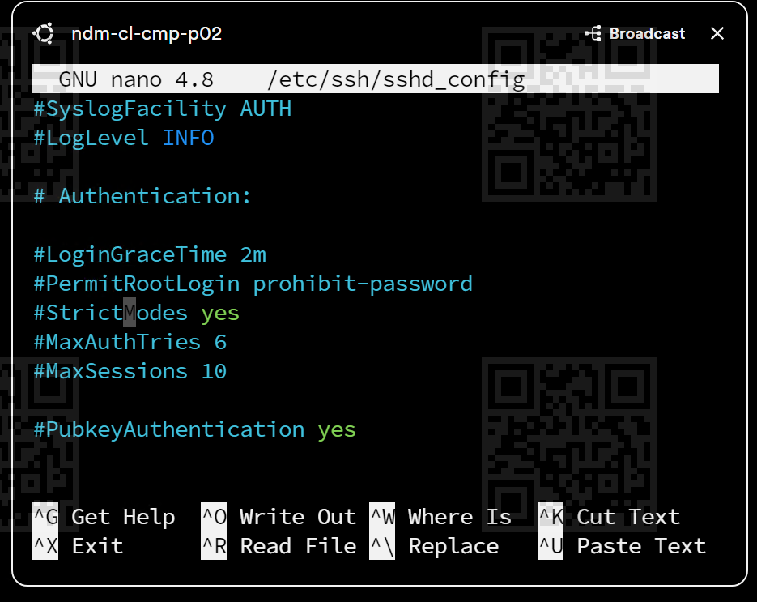
- Enable PermitRootLogin yes
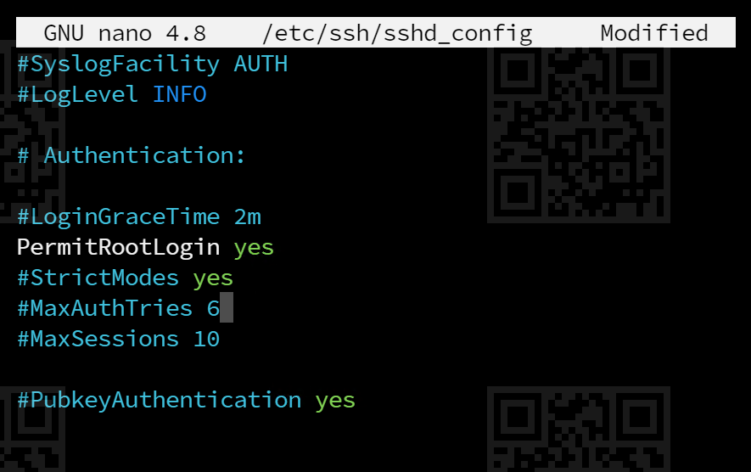
- sudo systemctl restart ssh

